

NBME SOPs

This document defines the Processes associated with NBME Joiners, Leavers, Movers and Access Requests.

Last updated: 9/30/2019

Contents

1. Access Requests 1

1.1 Process Flow Diagram 1

1.2 Process Flow Steps 2

1.2.1 New Folder Request Steps 2

1.3 Existing Folder/App Access Request Steps 3

2. Joiner or On-Boarding Process 5

2.1 Process Flow Diagram - FTE/Temp 5

2.2 Process Flow Steps 6

2.3 On-Boarding Consultant Process Flow Diagram 9

2.4 On-Boarding Consultant Process Flow Steps 10

3. Mover – FTE/Temp Department Transfer 11

3.1 Process Flow Diagram 11

3.2 Process Flow Steps 12

3.3 Maintain Previous Department Access Process Flow Diagram 13

3.4 Maintain Previous Department Access Process Flow Steps 14

4. Leaver – FTE/Temp 15

4.1 Process Flow Diagram 15

4.2 Process Flow Steps 16

4.3 Off-Boarding Consultant 17

4.3.1 Process Flow Diagram 17

4.3.2 Off-Boarding Consultant Process Flow Steps 18

5. Leave of Absence 19

5.1 Process Flow Diagram 19

5.2 Process Flow Steps 19

6. New Job Function 20

6.1 Process Flow Diagram 20

Glossary 21

Appendix A – Screen Exhibits 22

A1. This screen will be replaced with new ITCS catalogue item. 22

A2. Service NOW Ticket Appearance 23

A3. List of SN On-Boarding Tasks for Joiners (existing OUs) 24

A4. List of SN Off-Boarding Tasks for Leavers 25

A5. Process Flow Details Off-Boarding Consultant 26

A6. Building Access – New Employee 27

Appendix B - Managing Consultants at the NBME 28

Appendix C -Types of Workers (Definitions) 29

Appendix D (formerly part of Step 1 on page 2) 31

Appendix E (formerly part of Step 2) 32

**Exhibits**

Figure 1 Access Request 1

Figure 2 - Joiner Process Flow Diagram 5

Figure 3 - Mover Process Flow Diagram 11

Figure 4 - Mover Exception Process for Maintaining Previous Department Access Flow Diagram 13

Figure 5 - Leaver Process Flow Diagram 15

Figure 6 - Mover - Leave of Absence Process Flow Diagram 19

Figure 7 - New Job Function 20

Figure 8 – Alert – SLA time is at its threshold 22

Figure 9 - Potential SERVICENOW Ticket Appearance 23

Figure 10 - List of SN On-Boarding Tasks for Joiners 24

Figure 11 - List of SN Off-Boarding Tasks for Leavers 25

Figure 12 - Process Flow Details Off-Boarding Consultant 26

Figure 13 – Building Access – New Employee 27

# Access Requests

## 1.1 Process Flow Diagram

The following diagram illustrates the Access Control Process Flow. 

Figure Access Request

## Process Flow Steps

### 1.2.1 New Folder Request Steps

Use the following steps to create a new folder.

|  |  |
| --- | --- |
| **Step** | **Action/Explanation** |
| 1 | A ServiceNow ticket is opened for a **New Folder** request. |
| 2 | ITCS performs the following:   * Review the new folder access requirement. * Review the purpose and ensure a business need. * Assign to correct Access Fulfiller |
| 3a | If a new access structure, add it to the Claim.  If Birthright access, determine the type. They are Organizational, Divisional, or Other.   * Requestor confirms Name and Location. * The Comment field must be filled-in. * Windows Platform adds the folder to the Claim   If **not** Birthright access based on Scope, create AD Group.   * Requestor confirms Name and Location. * List users who need access. * Add required user(s) to the new AD Group (This grants access to the new folder). |
| 3b | IT Security adds the folder to Information Asset Inventory. |
| 4 | Windows Platforms closes the ServiceNow ticket. |

### 1.3 Existing Folder/App Access Request Steps

Use the following steps to request access to existing data. Full Time Employees make a self-request via ServiceNow Catalogue item. The same ServiceNow Catalogue item is used by the Manager to request access for Temps and Consultants.

|  |  |
| --- | --- |
| **Step** | **Action/Explanation** |
| 1 | ITCS manually assigns the request to a Data Owner for approval.  **Note**: The Data Owner can be anyone from any business unit. |
| 2 | The Data Owner responds within the SLA.  Access approved:  If No, reject and close the SN Ticket.  If Yes, go to Step 5.  or  If the Data Owner **does not** respond, the request is assigned to the Data Owner’s manager. Proceed to the next step. |
| 3 | The Data Owner’s Manager responds within the SLA.  Access approved:  If No, reject and close the SN Ticket.  If Yes, go to Step 5.  or  If the Data Owner’s Manager **does no**t respond, ITCS sends email to IT Security. Proceed to the next step. |
| 4 | IT Security approves/rejects the request.   * If IT Security approves the request, proceed to the next step. * If IT Security does not approve the request, reject and close the SN Ticket. |

Continued on the next page.

|  |  |
| --- | --- |
| **Step** | **Action/Explanation** |
| 5 | Does the Folder have an existing Group?  If Yes, go to Step 6.  If No, go to Step 7. |
| 6 | Access Fulfiller adds the Users to the existing Group (ITCS).  **Note**: Access approval message must be written in the comments of the SN ticket.   |  |  | | --- | --- | | **Access Fulfiller** | **Access Type** | | ITCS | Folder/Group Access | | AM Team (SN Group) | APP Access | | Windows Platform | No Group/Folder Exists |   Go to Step 9. |
| 7 | ITCS assigns the ticket to Windows Platform. |
| 8 | Windows Platform creates AD Group and provisions access. |
| 9 | Access Fulfiller closes the SN Ticket. |

# 2. Joiner or On-Boarding Process

## 2.1 Process Flow Diagram - FTE/Temp

The following diagram illustrates the Joiner Process.



Figure - Joiner Process Flow Diagram

## 2.2 Process Flow Steps

Use the following steps to process a new Joiner.

|  |  |
| --- | --- |
| **Step** | **Action/Explanation** |
| 1 | Create Employee ID.  HR Team manually creates an Employee ID from spreadsheet. |
| 2a | Submit New Hire Form.  HR completes the New Hire HTML screen. (Need example of form)  **Note**: Finance and other applications use information on this form. Refer to Appendix . When this form is submitted, an auto-generated email is sent to ITCS, Oracle and other groups. Refer to Appendix (Need example of form) |
| 2b | Create Employee Record in ERP.  HR creates the new employee record in ERP. |
| 3 | Create User ID.  A UserID is the first initial followed by the last name.  **Note**: A UserID is assigned by the HR Team. If the ID currently exists, a new ID is negotiated between the Oracle DBA, HR, and ITCS based on the existing accounts in AD and Oracle PROD Database. |
| 4 | Create Oracle PROD Account.  Oracle DBA creates Oracle PROD and DWPD Accounts which contain the Employee ID.  PROD & DWPD are the two “birthright” Oracle databases every new employee receives. This is handled programmatically through the SQL script. The kicking off of that script is still a manual process in that one of the Oracle DBA team members receives the new hire notification from HR and supplies the parameters to the script for execution.  **Note**: For every user, a new row gets appended to the core_employee table which lives in the PROD database. This row insertion is handled automatically by the creation SQL script and is not removed after user termination. |

Continued on the next page.

|  |  |
| --- | --- |
| **Step** | **Action/Explanation** |
| 5 | **<<<<<Contact Adam Martin for info>>>>>**  Create AD Account and populate the “Common Role” Attribute.  ITCS manually creates a User Account in AD account via a script. The script adds the user within the Domain Users OU which then (through GPO) adds them to the following four AD Groups.   * All - (NBME FTEs only) * Domain Users – Refer to Domain_Users_Group.csv in the Appendix __ for the list of groups that the user inherently becomes a member of when added to the “Domain Users” group.   + MobileConnectUsers   + BC- General Web Access   If the user is NOT an NBME FTE (Temp/Consultant), they must be removed from the “All” group manually by ITCS.  If the user to be created is a Domain Administrator, the account is be created by an AD Admin. |
| 6 | Sync Profile Create/Modify OID (Automated).  OID syncs the profile and automatically creates/modifies the OID.  An OID backend AD syncing script is run every 5 minutes. This creates a user record in OID for any new user account that it detects in the Domain Users OU in AD. There are 4 exception OU’s under Domain Users that the script will not check. They are:   * + - FRED Testing     - Service Accounts     - Domain Guests     - ECFMG Guests   **Note:**  OID is running two separate out of the box services:  First, an OID record is generated and stored in local LDAP and updated to AD & ERP – this OID is mandatory for ADFS - ERP SSO  *Note: These services will be moved to Syntax (ERP hosting company) in late 2019.*  Below listed are the two (6 & 7) services that are running regularly, gets activated when AD Users are changed or once in 5 minutes– exception OU for this list includes – Service Accounts, FRED Testing, Domain Guest & ECFMG Guest) | |
| 7 | Provisioning Profile Create User Account in ERP (Automated)  OID automatically creates the user account in ERP based on their employee record information. | |

Continued on the next page.

|  |  |
| --- | --- |
| **Step** | **Action/Explanation** |
| 8 | Update Script - ERP to AD Nightly Sync (Automated)  PS update script automatically syncs ERP to AD nightly.  Joiners Dept. migrated to new 2016 AD?  If Yes, continue to the next step  If No, go to step 11. |
| 9 | RSA IGL Provisions NBME birthright access which is AD groups/App access via Automated Business Role. |
| 10 | Sync Script - ERP to Oracle PROD twice per week (Automated).  End Process |
| 11 | Provision birthright groups via Common Role Data Sheets.  **Note:** The majority of entitlements associated will be file and folder shares, certain application authentication, and email DLs. |
| 12 | ITCS - Add roles and link Employee to User Account in ERP. |
| 13 | Initiate SN On-boarding Workflow.  ITCS initiates On-boarding Workflow via SN Link. It consists of spawning numerous child tickets for several IT Departments to provision the user to general NBME apps, setting up the new employee’s phone, along with other general tasks.  These tasks can be done in parallel.  End Process |

## 2.3 On-Boarding Consultant Process Flow Diagram

The following diagram illustrates the On-Boarding process for consultants.



## 2.4 On-Boarding Consultant Process Flow Steps

Use the following steps to on-board a new consultant.

|  |  |
| --- | --- |
| **Step** | **Action/Explanation** |
| 1 | Once the SOW is signed, on-boarding begins. |
| 2 | Manager submits consultant to the NBME *Consultant Management Application.*  At NBME Internet Home SHORTCUTS, click Apps & Forms.  Click Consultant Management Application. |
| 3 | Ticket is assigned to ITCS for verification. |
| 4 | Secondary approval from manager’s SVP  If Yes, proceed to the next step.  If No, go to Step 7. |
| 5 | Email is sent to manager to confirm the request was approved. Consultant record is marked active on the scheduled Start Date. |
| 6 | ServiceNow ticket generated by automated email to provision the account and request access/equipment.  End |
| 7 | Email notification sent to manager, informing them the request was rejected. Pending consultant record is removed. |

# 3. Mover – FTE/Temp Department Transfer

## 3.1 Process Flow Diagram

The following diagram illustrates the Mover Process.



Figure - Mover Process Flow Diagram

## 3.2 Process Flow Steps

Use the following steps to process a FTE/Temp Mover.

|  |  |
| --- | --- |
| **Step** | **Action/Explanation** |
| 1 | The transfers effective date is negotiated and finalized between the Effective Manager, Previous Manager, and HR. |
| 2 | HR submits a Building Access Request Form.  If the form does not have this field, need to add/update form. |
| 3 | Collaborative Services transfers the user’s phone extension if the user moves location. |
| 4 | Does the user require overlapping access?  If Yes, continue to the next step.  If No, go to step 4b. |
| 4a | Go to the Mover Exception Process on the next page. |
| 4b | Modify ERP Record (Dept., Job Title, and ERP Roles if needed). |
| 5 | Modify Common Role Attribute in Mover’s AD account on effective date. |
| 6 | ERP to AD Scheduled Script modifies the AD Attributes the same night as ERP effective date. |
| 7 | Remove Mover from existing AD groups and provision new birthright AD groups via Common Role data sheet.  End Process. |

## 3.3 Maintain Previous Department Access Process Flow Diagram

The following diagram illustrates the Exception Process for Maintaining Previous Department Access.



Figure - Mover Exception Process for Maintaining Previous Department Access Flow Diagram

## 3.4 Maintain Previous Department Access Process Flow Steps

Use the following steps to process the maintaining of previous department access.

|  |  |
| --- | --- |
| **Step** | **Action/Explanation** |
| 1 | Add Mover to BR groups according to their data sheet. |
| 2 | Open SN Request to remove the Users previous role group access according to their previous role data sheet AFTER the specified temporary time period.  **Note**: Movers Previous Department and Temporary Access Time Period is included in the ticket. IT Security is added as a watcher to ensure access is revoked. |
| 3 | Revoke the Mover’s previous Department Access according to the Role Data Sheet.  End. |

# 4. Leaver – FTE/Temp

## 4.1 Process Flow Diagram

The following diagram illustrates the Leaver Process.



Figure - Leaver Process Flow Diagram

## 4.2 Process Flow Steps

Use the following steps to process a FTE/Temp Leaver.

|  |  |
| --- | --- |
| **Step** | **Action** |
| 1 | HR Team completes the Leaver Form within RSA IGL. |
| 2 | RSL IGA emails Leaver’s Manager and Account-Termination@nbme.org. |
| 2a | RLS-IGA disables the Leavers Exchange email. |
| 3 | RSL-IGA disables AD Account. |
| 3a | Invoke Power Shell script in Step 7. |
| 4 | Revoke RSA Connected Structured Data Entitlements. |
| 5 | After receiving email, ITCS Initiates Off-Boarding workflow via ServiceNow. |
| 6a | ITCS disable/remove Terminated User from ITCS Listed Application. |
| 6b | Customer First deactivates SalesForce Account. |
| 6c | Collaborative Srvs Desktop performs Desktop Listed Off-Boarding Tasks. |
| 6d | Oracle DBA disables Oracle PROD Account. |
| 6e | Collaborative Srvs Unified Comm removes Phone & Disable Mobile Connect Account. |
| 6f | Facilities revoke Building Access. |
| 7 | Automated PowerShell script runs daily. This script moves AD Account to “Disabled Accounts”.  OU – This script also revokes all AD Group entitlements for this user. |
| 8 | Automate 3d Power Shell script deletes AD Account if 45 days have passed after Step 7. |

## 4.3 Off-Boarding Consultant

## 4.3.1 Process Flow Diagram

## 4.3.2 Off-Boarding Consultant Process Flow Steps

Use the following steps to Off-Board a consultant.

|  |  |
| --- | --- |
| **Step** | **Action/Explanation** |
| 1 | When their contract ends, an email is sent to their manager. |
| 2 | Manager forwards this email to ITCS. |
| 3 | ITCS disables AD account if it exists – repeats the entire off-boarding process similar to FTE… (Just in case to remove extra access like JIRA, mobile connect etc.) |
| 4 | Consultant account within Consultant Management Application is switched to an “Inactive” state automatically via daily script. |

# 5. Leave of Absence

## 5.1 Process Flow Diagram

The following illustrates the FTE Leave of Absence process.



Figure - Mover - Leave of Absence Process Flow Diagram

## 5.2 Process Flow Steps

Use the following steps to process a LOA.

|  |  |
| --- | --- |
| **Step** | **Action** |
| 1 | When an employee takes long term leave of absence, HR Notifies ITCS of LOA. |
| 2a | Edit subcategory “Employee Status” in ERP to indicate employee is LOA. |
| 2b | ITCS manually executes PS script via MBME Admin Menu to give user “email only” access. |
| 3 | Disable Oracle PROD account via Script. More details |
| 4 | When employee returns, send email (include ITCS) informing the LOA return. |
| 5 | Manually execute PS Script via NBME Admin Menu to re-provision user’s original access. |
| 6 | Re-enable Oracle PROD account via Script name (different script from Step 3). |

# 6. New Job Function

## 6.1 Process Flow Diagram

The following illustrates the adding of a new job function.



Figure - New Job Function

# Glossary

|  |  |
| --- | --- |
| **Term** | **Definition** |
| AD | Active Directory or Application Development Team. |
| AM | Application Management Team. |
| Birthright Access | NBME standard access granted when an employee is hired at NBME. |
| Data Owner | Responsible for and owner of the data. The Data Owner approves or rejects these requests mentioned in the requirements. |
| ERP | Enterprise Resource Planning |
| ITCS | Information Technology Customer Service. |
| RSA IGL | Software for managing and reviewing access to structured data and AD groups. |
| SN | ServiceNow ticketing system at NBME. |

# Appendix A – Screen Exhibits

## A1. This screen will be replaced with new ITCS catalogue item.

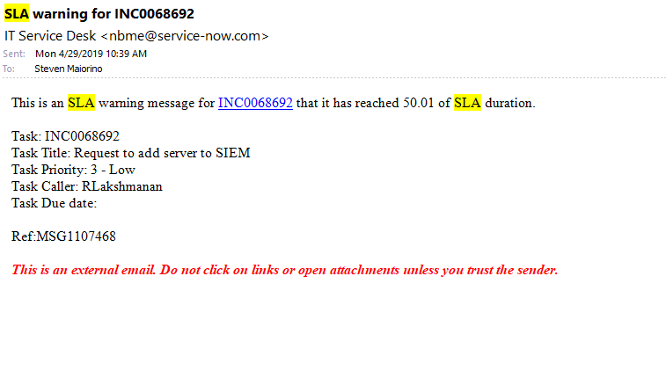

Figure – Alert – SLA time is at its threshold

## A2. Service NOW Ticket Appearance

Reporting: generate a SN report that shows all Access Request tickets that are “in progress”. This will help ITCS in tracking the SLAs if we cannot generate automatic alerts for them.

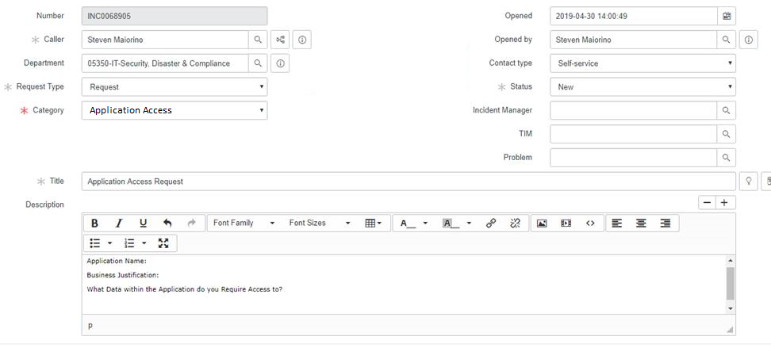

Figure - Potential SERVICENOW Ticket Appearance

## A3. List of SN On-Boarding Tasks for Joiners (existing OUs)

The following lists the Joiner tasks.

|  |  |  |  |
| --- | --- | --- | --- |
| **Department Assigned** | **Main Point of Contact** | **Task** | **Fulfillment Script(s)** |
| ITCS | Sandie or Elaine | New Hire Orientation | N/A |
| ITCS | Lois | Everbridge Setup | N/A |
| ITCS | Lori | WebEx Setup | N/A |
| ITCS | Beth | ServiceNow Setup | N/A |
| Desktop | Team Member | Desktop Setup | N/A |
| ITCS | Lori | ERP Setup | N/A |
| ITCS | Lois | Confluence Setup | N/A |
| Unified Communication | Denaya, Co-op, or Paul | Phone / Extension Setup and Mobile Connect | N/A |
| ITCS | Beth | DUO Setup | N/A |
| ITCS | Lori | DL / Group membership | N/A |
| ITCS | Lois | JIRA Setup | N/A |
| ITCS | Lori | Network Acct. Setup | N/A |
| Web Services and Database Administration | Team Member | Account creation in Database | Add_prod_user.sql |

Figure - List of SN On-Boarding Tasks for Joiners

## A4. List of SN Off-Boarding Tasks for Leavers

The following lists the Leaver tasks.

|  |  |  |  |
| --- | --- | --- | --- |
| **Assigned Department** | **Main Point of Contact** | **Task** | **Fulfillment Script(s)** |
| ITCS | Beth Hopp | Close eRoom account(s) | N/A |
| Customer First | Team Member | Deactivate Salesforce Account |  |
| ITCS | Beth Hopp | Disable ServiceNow Account | N/A |
| Desktop | Team Member | Pickup Desktop/Laptop | N/A |
| Web Services and Database Administration | Team Member | Disable Oracle DB | Terminate_employee.sql |
| ITCS | Lori O’Brien | Remove WebEx Account | N/A |
| Desktop | Team Member | Remove CB from machine | N/A |
| ITCS | Lois Harwood | Disable JIRA Account | N/A |
| ITCS | Lois Harwood | Remove Everbridge  Account | N/A |
| Desktop | Team Member | Remove McAfee from machine |  |
| ITCS | Lori O’Brien | Disable Network Account | N/A |
| ITCS | Beth Hopp | Remove DUO Account | N/A |
| ITCS | Lois Harwood | Disable Confluence  Account | N/A |
| ITCS | Lori O’Brien | Remove ERP Privileges | N/A |
| ITCS | Lois Harwood | Remove User from ITS Prod and Staging | N/A |
| Unified Communication | Denaya, Co-op,  or Paul | Remove phone/Disable MobileConnect | N/A |
| ITCS | Lori | Check ownership of SharePoint site | N/A |
| ITCS | Lori O’Brien | Check if Employee was a Manager/SVP/etc... | N/A |
| Facilities Mgmt. | Facilities | Revoke Building Access | N/A |

Figure - List of SN Off-Boarding Tasks for Leavers

## A5. Process Flow Details Off-Boarding Consultant

|  |  |  |
| --- | --- | --- |
| **Assigned Department** | **Assigned To** | **Task** |
| ITCS | Beth Hopp | Close eRoom account(s) |
| Customer First | Team Member | Deactivate Salesforce Account |
| ITCS | Beth Hopp | Disable ServiceNow Account |
| Desktop | Team Member | Pickup Desktop/Laptop |
| Web Services and Database Administration | Team Member | Disable Oracle DB (as explained in On-boarding process) |
| ITCS | Lori O’Brien | Remove WebEx Account |
| Desktop | Team Member | Remove CB from machine |
| ITCS | Lois Harwood | Disable JIRA Account |
| ITCS | Lois Harwood | Remove Everbridge Account |
| Desktop | Team Member | Remove McAfee from machine |
| ITCS | Lori O’Brien | Disable Network Account |
| ITCS | Beth Hopp | Remove DUO Account |
| ITCS | Lois Harwood | Disable Confluence Account |
| ITCS | Lori O’Brien | Remove ERP Privileges |
| ITCS | Lois Harwood | Remove User from ITS Prod and Staging |
| Unified Communication | Denaya, Hazem, or Paul | Remove phone/Disable MobileConnect |
| ITCS | Lori | Check ownership of SharePoint site |

Figure - Process Flow Details Off-Boarding Consultant

Consultant account within Consultant Management Application is switched to an “Inactive” state automatically via daily script.

## A6. Building Access – New Employee

The following screen exhibit shows the Building Access – New Employee form.

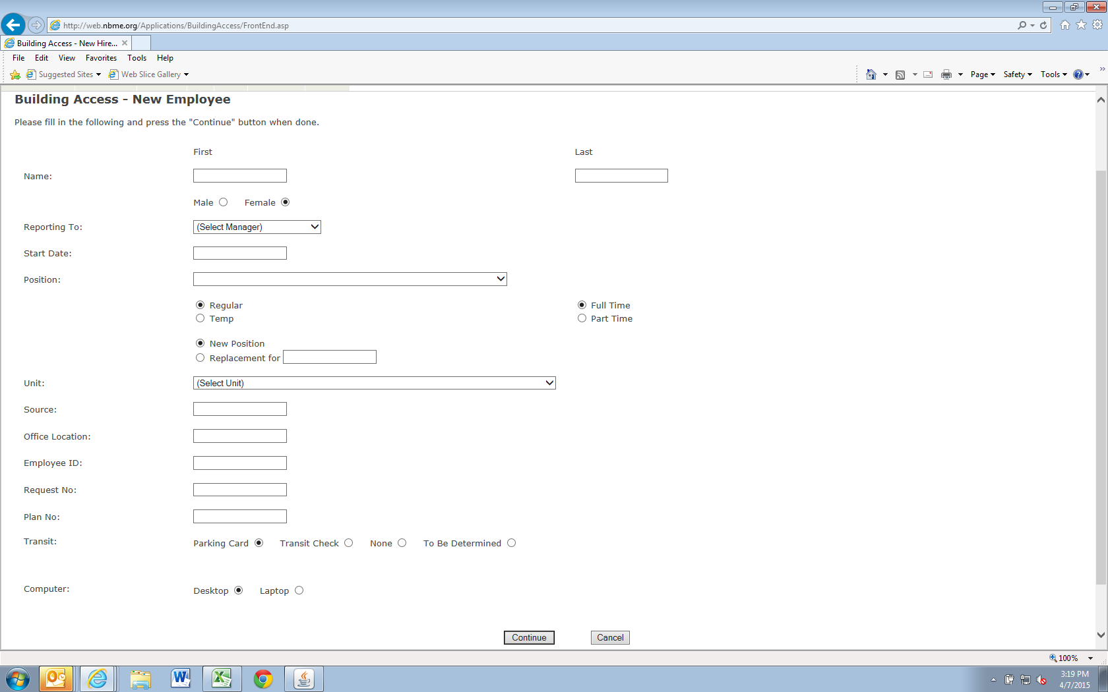

Figure – Building Access – New Employee

# Appendix B - Managing Consultants at the NBME

The NBME engages several types of workers including employees, agency temps, Drexel co-ops, interns and consultants to accomplish the goals for the organization. Human Resources is responsible for facilitating the recruiting, on-boarding, and off-boarding of most of the NBME workforce, except for consultants. Consultant needs are determined by NBME service owners who work with Legal and Finance to procure services, IT when access to NBME systems is needed, and Facilities when the consultant will be working on site. Visibility of those consultants who require access to NBME systems, and the timely removal of system access when a consulting engagement is complete, are two major gaps in our ability to adhere to access management best practices.

To close this gap, a new system called the Consultant Management Application is now available. All consultants who require access to the NBME network will be tracked in this system. When the consultant’s end date arrives, the system will automatically disable the consultant’s access to NBME systems.

All active consultants with NBME network access have been pre-entered into the Consultant Management Application. Click [here](http://webdev.nbme.org/applications/NewConsultantHire/Default.aspx) to view the consultants who are providing services to you.

**If you have engaged a consultant**, please do the following.

➢ Review the End Date o If your consultant will need to perform services beyond the current End Date, click Edit and enter the revised Scheduled End Date. Ensure a contract addendum and requisition to extend the end date is in place, where appropriate.

**NOTE: The consultant’s account will be automatically disabled the day following the End Date.** The system will send an email notification at the following intervals alerting you that a consultant’s access is ending. ▪ 2 weeks prior to the End Date

▪ 1 week prior to the End Date

▪ 1 day prior to the End Date

**If you will be engaging a consultant**, please do the following.

➢ Review the Consultant Management Process diagram further down in this announcement.

➢ Once a requisition has been entered and approve in ERP and the subsequent purchase order has been issued, go to the Consultant Management Application (you will find it on the NBME Intranet, under Apps & Forms) and click Request a Consultant Account. Instructions are available in the application.

➢ Purchasing will approve (or reject, if the PO hasn’t been approved), and the consultant management application will auto-generate an email notification to IT Customer Service to create an account and fulfill the access requested.

If you have any questions regarding system access, please contact IT Customer Service at x9222.

Proceed to Appendix C on the next page for more information on types of workers.

# Appendix C -Types of Workers (Definitions)

Below are characteristics for the various types of workers that comprise the NBME workforce. These are meant to be used as general guidelines. If you have a workforce need, and are unsure of the type of worker to fulfill that need, please contact Human Resources for guidance.

|  |  |  |  |  |  |
| --- | --- | --- | --- | --- | --- |
|  | Consultant | Agency-Temp | Drexel Co-op | Intern | Employee |
| Control | The consultant controls the way in which they do their work. The NBME (or service owner is interested only in the consultant’s results. | NBME can exercise complete control over the way in which an agency-temp, Drexel Co-op, intern, or employee completes a job (how, when, and where they to the work, and with what equipment/access). | | | |
| Supervision | Consultants generally work unsupervised. | Agency-temps, Drexel co-ops, interns, and employees generally work under extensive supervision (depending on knowledge, skills, and experience). | | | |
| How Work is Done | Consultants can generally set their own hours and do the job in their own way. The Service Owner will review only the finished job. | Agency-temps, Drexel co-ops, interns, and employees have to follow instructions given to them by the service owner/NBME to do their job in a certain way. | | | |
| Duration | Statement of Work (SOW) specifies services, deliverables, and timeline and fees for which work will be completed. | Assignment is limited to a certain period of time, maximum 12 months, to accommodate a temporary shortage in resources to meet demand. | Assignment is limited to less than 6 months. | Assignment is typically limited to 8 weeks, but may vary. | Employment is at will. |

Continued on the next page.

|  |  |  |  |  |  |
| --- | --- | --- | --- | --- | --- |
|  | Consultant | Agency-Temp | Drexel-Co-op | Intern | Employee |
| Recruiting | Service Owner is responsible for selecting consultant. | Human Resources facilitate the recruiting process based on a job description including duties and responsibilities. | | | |
| On-boarding / Off-boarding | The NBME Service Owner determines the necessary network access so the consultant can perform the work. The service owner ensures the deliverables meet the acceptance criteria and performs contract close out. | Human Resources facilitate the on-boarding process so the worker can be as productive as possible when they start their assignment at the NBME.  Human Resources tracks End Dates for agency-temps, Drexel co-ops, and interns and facilitates the termination process for these workers, as well as employees. | | | |
| Training | Consultants, agency-temps, Drexel co-ops are not provided training by the NBME. | | | | Employees are provided training (on or off site) to develop their skills and grow within the organization. |

# Appendix D (formerly part of Step 1 on page 2)

1. Access associated with a Business Roles (folders and applications) is automatically granted when a person joins or transfers based on attributes in ERP.
   1. If someone is temporarily in an “acting” role, HR or the supervisor opens a request via Service Now specifying the additional business role. IT enables the additional access associated with the second role.
2. Additional access beyond the birthright access can be requested via Service Now.
   1. For folders, the access request must be approved by the folder data owner before it can be fulfilled.
   2. For applications, the access request must be approved by the application data owner before it can be fulfilled.
   3. The requestor must provide a business justification when submitting an access request.
   4. Data classification is established for all folders and applications. It is used to prioritize access reviews, and potentially for deriving other governance rules.
3. Self-requested access.
   1. Only regular employees may submit an access request. All user self-requested access must be approved by the data owner before fulfillment.
      1. If access is for highly restricted data, this is noted in the email notification to key the data owner.
   2. Only one object (folder, application) can be requested per Service Now ticket. Task Force requested to use layman’s terms in place of object.
   3. Should the manager be copied on the request notification? Yes, for awareness. Not approve.
   4. What happens if a temp enters a request? Reject the request.
      1. Forward to manager for approval? No.
4. Requesting access for others.
   1. The ability to request access for others is limited to a defined group of employees. (e.g., managers, and data owners)
   2. Access requests is limited to 1 object (folders, applications, SharePoint, etc.) per request.
   3. If the requester is the owner of the object being requested for others, access approval is not necessary. It is implicit.
5. For temporary access add a date and time attribute in AD / Access Request for the access period. Create an alert when this time frame exceeds.

# Appendix E (formerly part of Step 2)

1. Access Request Approval time.
   1. For data owners - one day.
   2. Then escalated to manager for one day before end of line approval with IT Security.
   3. The SLA is currently 2 days. We will need to add this to the communications plan.
   4. Total time for approval is 2 days.
2. Who needs access – This information is used to propose Name and Location.
   1. Inter Dept
   2. Intra Dept
   3. Scope (Who)
   4. Purpose (Why)
3. Folder Name.
4. Data Classification.
5. Data classification will be included for folder structure - Internal, Public, Restricted, and Highly Restricted
6. Read, Write, or R/W access Is there an existing folder location that has the same scope?
7. Data Owner.
8. Amy mentioned that currently the wrong people are being contacted for approval. IT CS is obtaining the data owner based on the people who create/modifies the files most frequently.
9. Currently Data Owner of folder access is different from folder owner - Need to get the correct data owner and to be replaced with the folder owner.
10. We have the data owners for the root level of I drive will make sure the data owners are identified as folders are moved to U and W drives.
11. Inform IT Security